Confidence Levels

Can be used along with or instead of P value
A sample of a population will always have some margin of error.
For example looking for the average size of weight of apples in an orchard from a sample will never give a spot on representation but will allow to assess the width of a confidence interval (a measurement within which the true mean lies) These intervals can be estimated by looking at the means of several samples form the same population.
A standard confidence interval might be 95% (the mean of the total population lies within 5% of the samples mean therefore we can take the samples to be 95% accurate when reflecting the population mean)
A more varied population or smaller sample would lead to a lower confidence level for example 92%.
So the confidence interval of how a sample represents a larger population depends on factors about the sample.

P Value (T-Testing/Hypothesis Testing)
P value less than 0.05 (5%) indicates statistically that the two samples under comparison are unlikely to hold the same values or came from the same sample. Thus disproving the null hypothesis that there is no difference between the values.

Error Bars
Error Bars are used to add further detail to charts and plots, they can show the Min/Max values, confidence intervals, and measures of deviation.
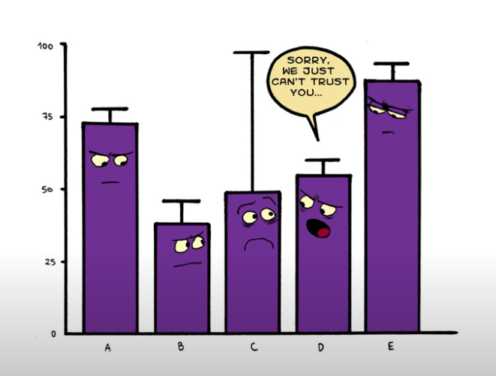

Standard Deviation
A measurement that shows how much a set of values is spread around the mean of those values. It quantifies the variation in a set of values.
Standard Error
Standard error is the standard deviation measurement taken from a number of standard deviation measurements of several samples or data sets. It quantifies the variation in multiple sets of values.
NB. The Standard Deviation in most cases in the measurement that should be used for a single set of values or a sample even though the SE can be calculated from SD.
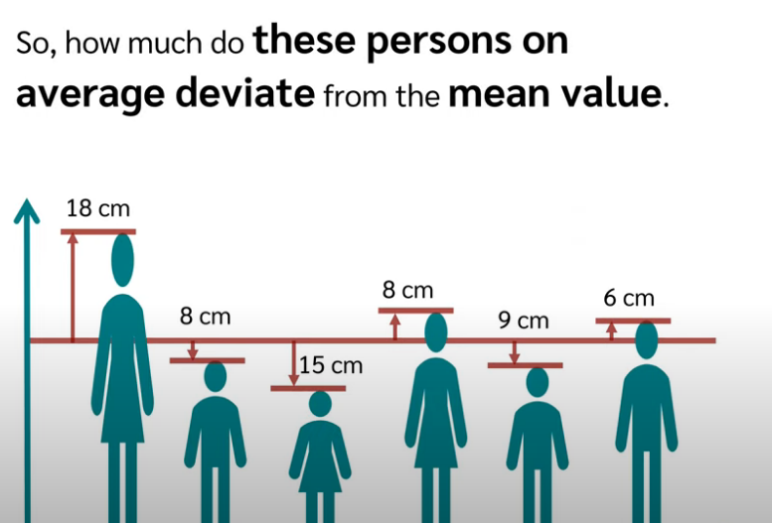
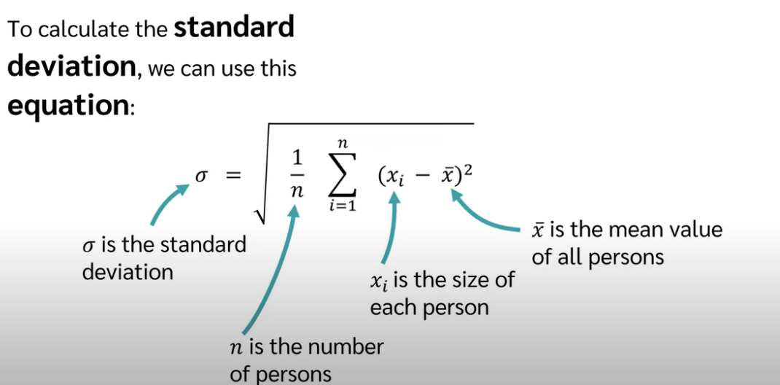

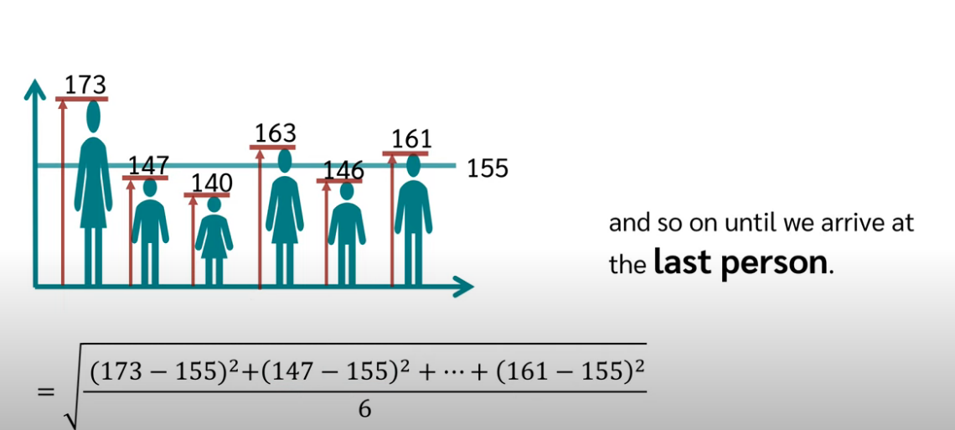
On average each person deviate 11.5 cm from the mean.
SD = 11.5cm
Variance = 132.25

Standard Deviation uses the root values so stays in the same measurement scale as the actual values whereas the Variance is the squared SD.
The SD is more intuitive to use whereas Variance can be used to upscale negative values etc.

